**Cheyenne Nave**

**Project One**

**October 2, 2024**

## About the Project/Project Title

This project provides Grazioso Salvare, an animal-training company, information about dogs at various animal shelter locations to identify and categorize available dogs for life-saving training purposes.

## Motivation

Grazioso Salvare trains dogs for search and rescue operations. They have partnered with a non-profit organization in Texas to provide information about local animal shelters. I have imported the database and built an index to navigate it properly, while also using CRUD operations to create, read, update, and delete entries.

## Getting Started

To start, follow the steps below:

* Ensure Mongo is downloaded on your local hardware. I am using Linux and Mongo has been provided.
* Open a terminal and start a Mongo session
  + Access by typing “mongosh”
* Import the database labeled “AAC”
* Use the database with keywords “use AAC”
* To navigate search, use the findOne() function in Mongo
* Animals can be searched with ID number, breed, type, and name
* The Create function, Read function, Update function, and Delete function can be used with dot notation to modify the dataset.

## Installation

Install Mongo for database use and navigation. Also, ensure a Python reader/writer is installed. Pymongo is necessary.

## Usage

Below is evidence of the project working along with explanations.

### Code Example

The above screenshots display the Python code for Creating, Reading, Updating, and Deleting (CRUD) data for the database.

*

These tests are implemented to make sure the code is connecting to the database properly. Each cell is a different test for the CRUD functions. Results should execute properly according to each test – in order.

An octopus is obviously not a dog. It was entered to display functionality of the project. In the Mongo terminal, we can see that after being created and read, the data was inserted into the database correctly.

Above displays the results of a search of the same Octopus we created earlier.

After using the Update method, the outcome_type has been changed from “Not-Adopted” to “Adopted”.

Finally, we can see the results of the same animal after using the Delete function. Blue the octopus no longer exists according to its ID A999902. In summary, all CRUD functions work.

Below are more examples of import, authentication, login, index use, explain-function, and basic searching.

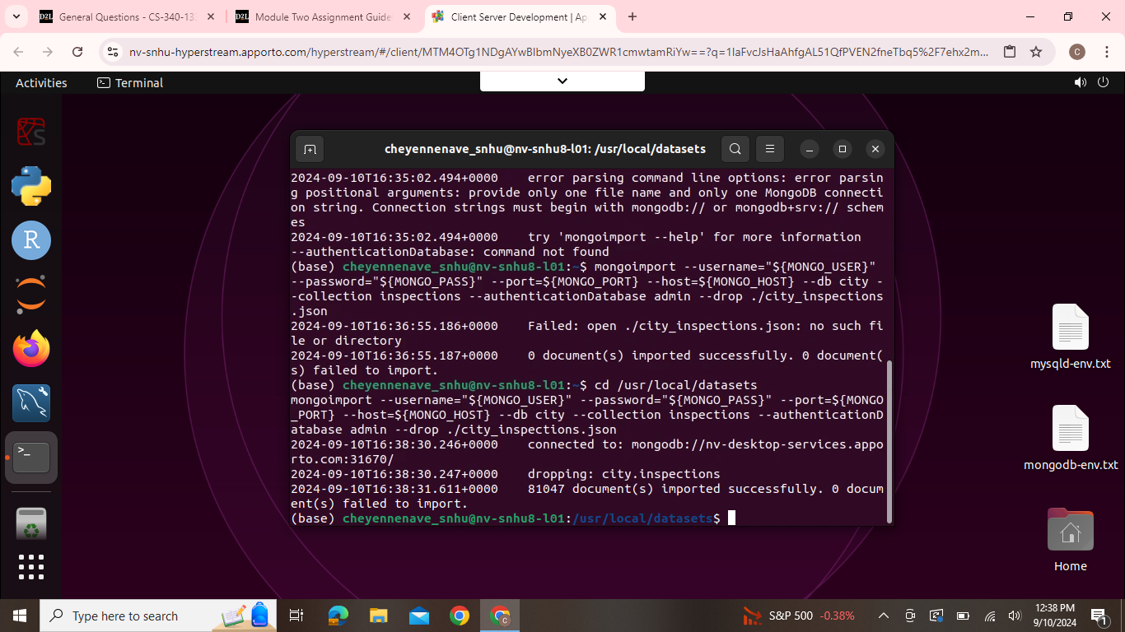

This is how to import the database – csv file.

Above is an example of the explain function that can be used.

User creation and displays can be toggled through admin database or the AAC database used for this project – if Grazioso Salvare is so inclined to add or manage their users. Also, basic login procedures are provided.

Finally, here we see the compound index that has been created along with a basic explain function to explain data based on search results through the index.

*Note:* This README has been updated for all CRUD functions

## Contact

Cheyenne Nave

Cheyenne.nave@snhu.edu